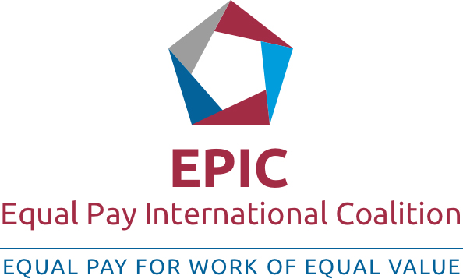

GOVERNMENT ENGAGEMENT
Led by ILO, UN Women and the OECD, EPIC is a multi-stakeholder initiative comprising government entities including ministries responsible for labour and employment, ministries responsible for gender equality and national statistical offices, international and national employers’ and workers’ organizations, relevant UN entities, the private sector, international civil society organizations and academia.
For EPIC to operate credibly, effectively and strategically, it is key that the committed parties show a genuine and proven commitment to achieving equal pay for work of equal value.
At least SIX out of the below criteria are to be met at the moment of signature of within the THREE YEARS period of time.
Criteria | Status (source of verification, if needed)
Ratification of ILO Equal Remuneration Convention, 1951 (No.100) or verifiable steps being taken to ratify it; | The Convention is ratified. No further source or verification is needed.
Legislation in line with ILO Convention No. 100; | The current legislation is not in line with ILO Convention No. 100. Convention forces the introduction of equal pay for equal work. While there is no clearly shaped definition for equal pay and no assessment methodology, it would be hard to commit to this particular criterion.
Ratification of the UN Convention on the Elimination of all forms of Discrimination against Women, 1976 (Article 11d) | The Convention is ratified. No further source or verification is needed.
Adherence to the Recommendation of the 2013 OECD Council on Gender Equality in Education, Employment and Entrepreneurship and the 2015 Recommendation of the OECD Council on Gender Equality in Public Life | The Parliamentary Thematic Inquiries of 2019 on Women’s Participation in State Funded Economic Development Programs, and Women’s Participation in Vocation Education Programs are indications of working towards the recommendations. 4 municipalities in Georgia have committed to “European Charter for Equality of Women and Men in Local Life”, indicating steps towards the implementation of the recommendations.  Texts of both recommendations (2013 and 2015) are acceptable and possible to adherence within the next three years. Therefore,  Government of Georgia is committed to and will be working towards this goal
Sex-disaggregated data on wages are collected | Sex-disaggregated data on wages are collected by the National Statistics Office – GeoStat.  Source of verification: Labor Force Survey (LFS)
Policies or practices that encourage pay transparency are in place | While there is no such policy in place at a present moment, such policies may be encouraged (not mandated) within the three years. Therefore, Government of Georgia is committed to and will be working towards this goal
In countries where minimum wages are set by sector or occupation, minimum wages cover also sectors and occupations where women workers predominate | No minimum wages are set in Georgia. It would be hard to commit to this particular criterion.
National bodies (e.g. equal employment opportunities bodies or tripartite bodies) that address equal pay are in place | Tripartite Social Partnership Commission might serve as such national body, through which encouragement of equal pay might be considered. Cooperation might be strengthened within the three years. Therefore, Government of Georgia is committed to and will be working towards this goal.
Laws, policies or measures to facilitate work-family reconciliation or increase the representation of women in companies’ boards are in place | National Bank of Georgia has already introduced some measures on gender quotas in boards.  Inter-agency Gender Equality Commission plans to issue further guidelines on the matter.  UNW continues work with the private sector.  Therefore, Government of Georgia is committed to and working towards this goal
Offer in-kind or financial support as contributions to key EPIC outputs

SIGNATORS to the Document:

- Minister of Internally Displaced Persons from the Occupied Territories, Labour, Health and Social Affairs of Georgia
Alternative: Deputy Minister of Internally Displaced Persons from the Occupied Territories, Labour, Health and Social Affairs of Georgia

- Chair of the Inter-Agency Commission on Gender Equality, Violence Against Women and Domestic Violence [Human Rights Council. Administration of the Government]

- Chair women of the EPIC

